Online Auction & Bidding Platform

Base URL
http://localhost:8080/api/name

Auth — Register
ADMIN
POST /auth/register
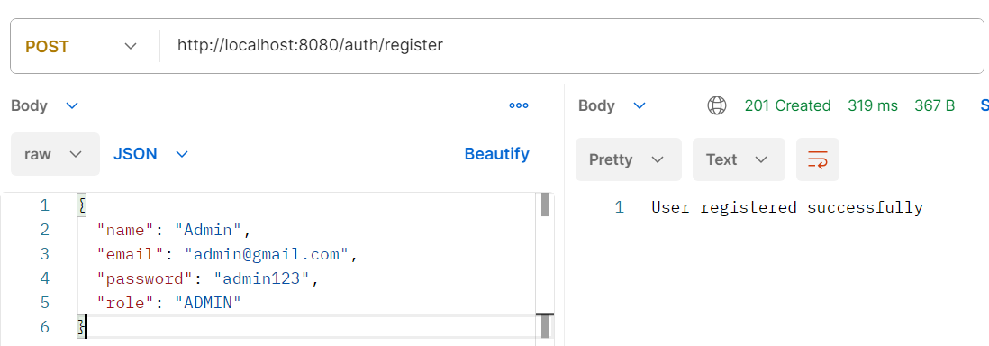
SELLER
POST /auth/register
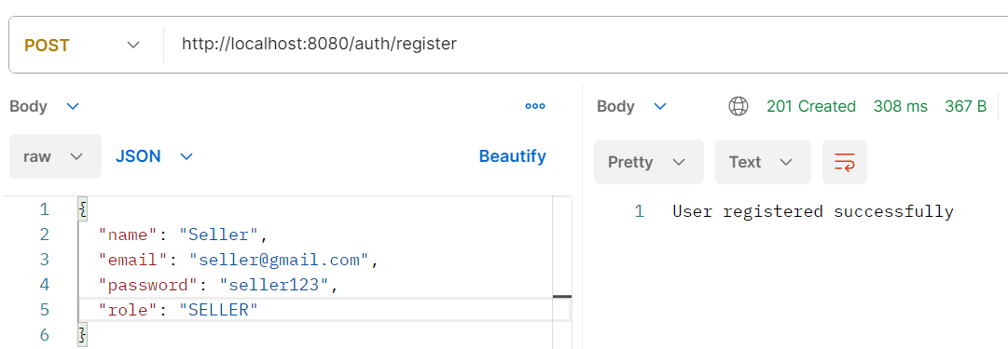
BUYER
POST /auth/register
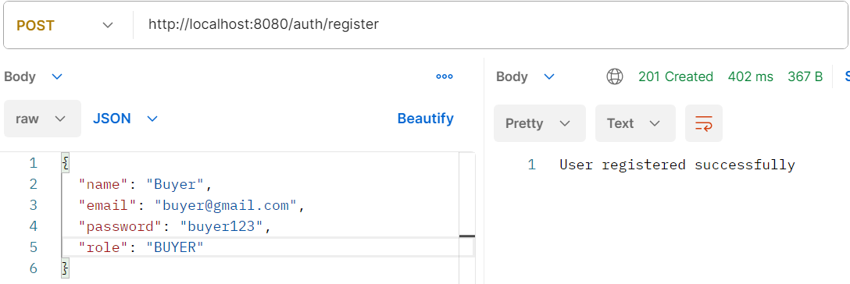
ADMIN
POST/auth/login
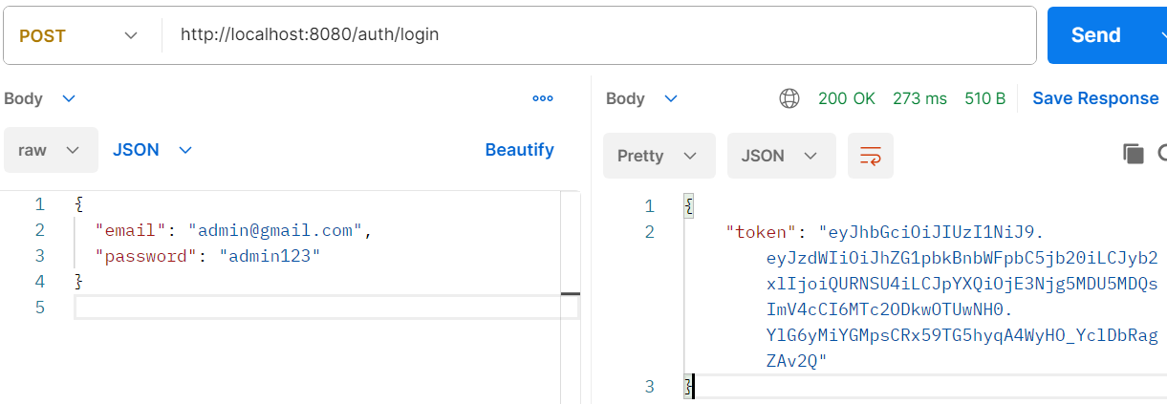
SELLER
POST/auth/login
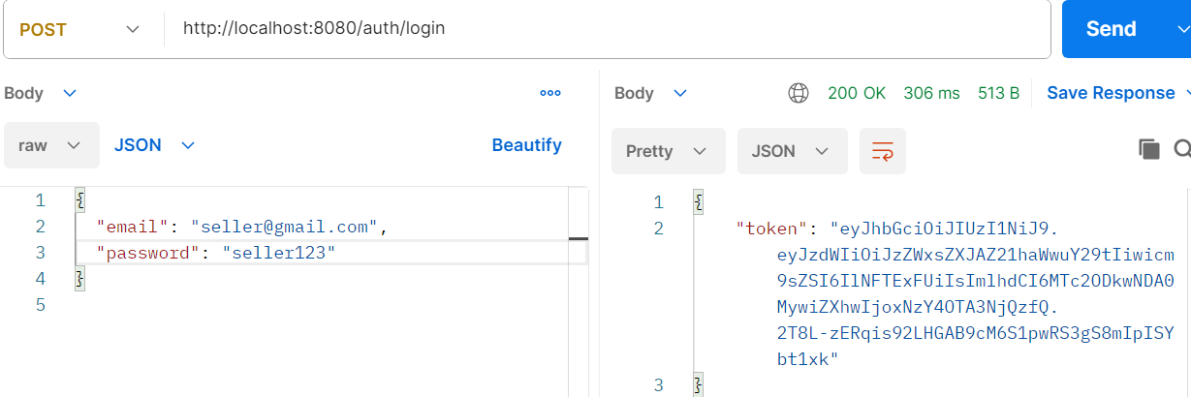
BUYER
POST/auth/login
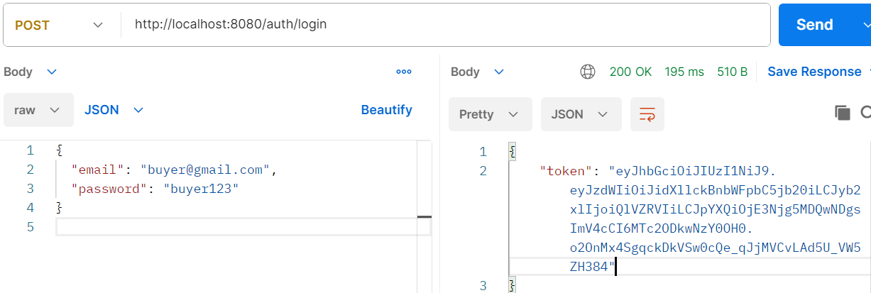

SELLER – Upload their product:
POST/products
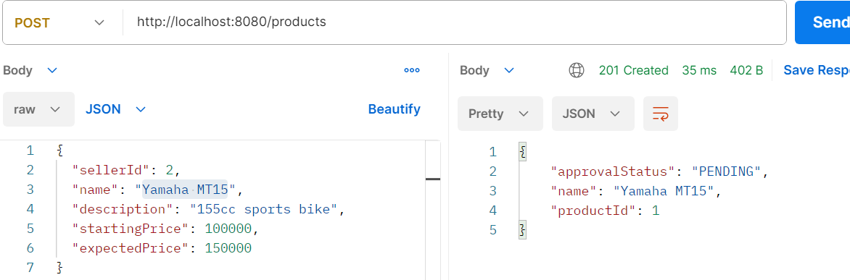
ADMIN – Approves Product :
PUT/products/admin/approve/1
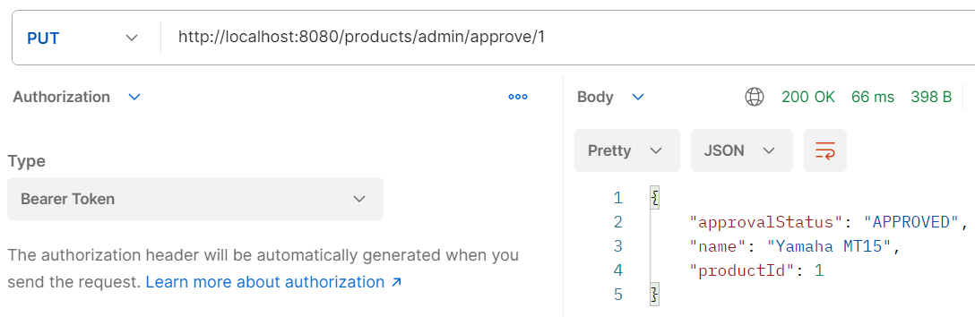
ADMIN – Schedule the auction:

POST/ admin/auctions

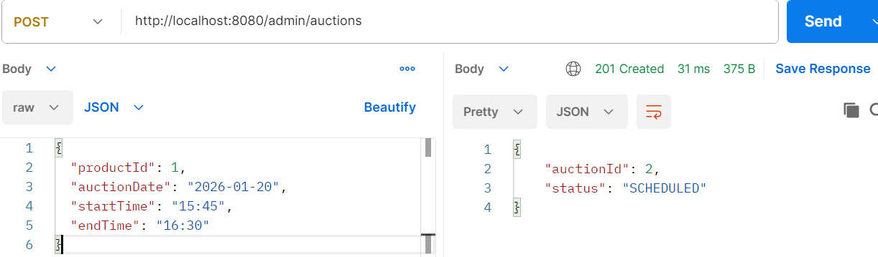

BUYER – See the active auctions:
GET/auctions/buyer/active
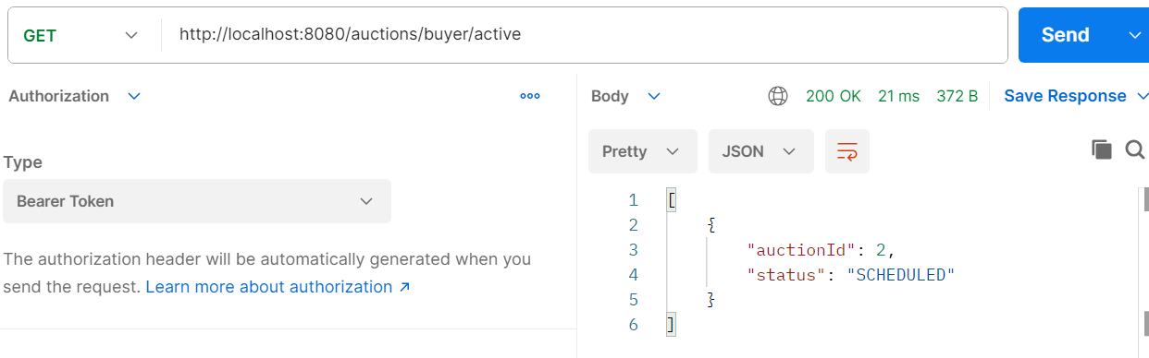
BUYER – Place his bids :
POST/auctions/2/bids
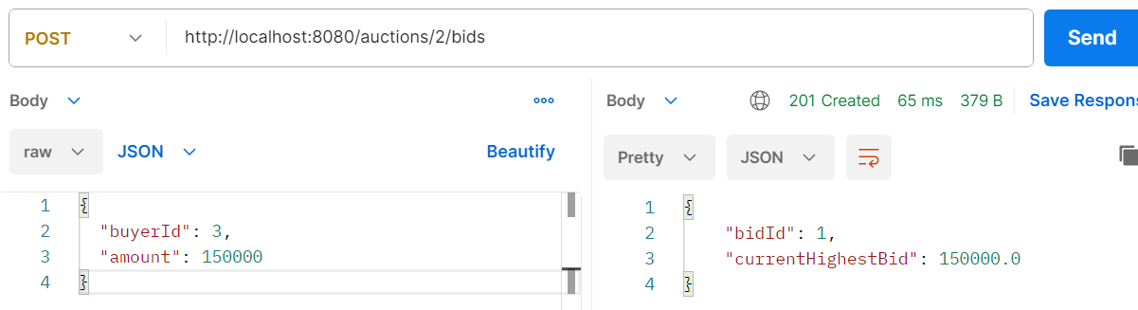
ADMIN – Close the auction :
POST/ auctions/close/2
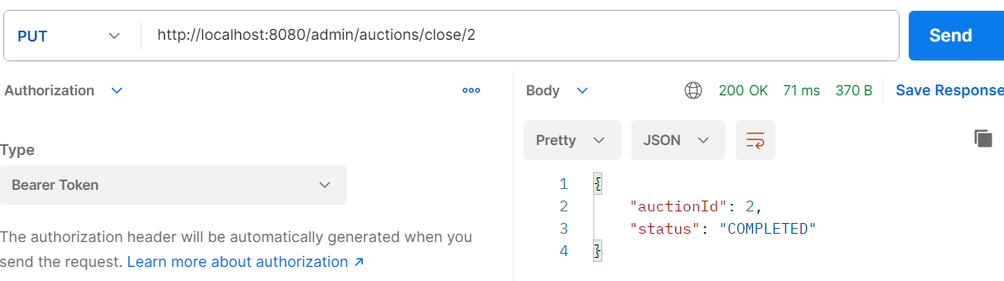

BUYER – Payment :
POST/ payments/2
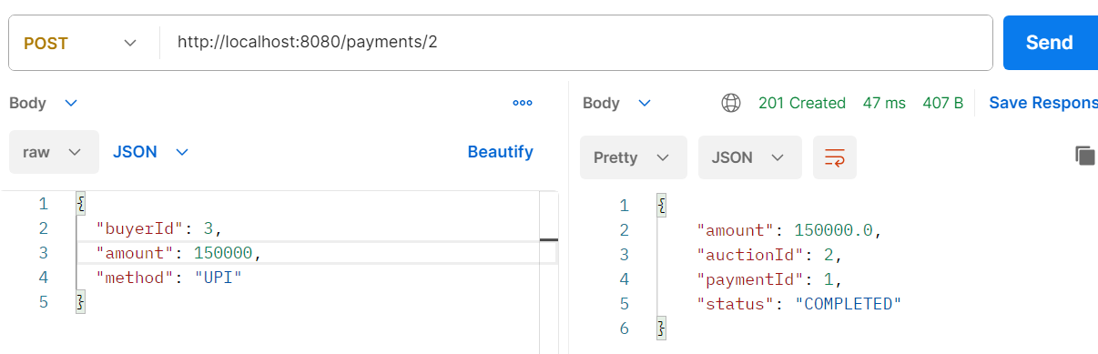
BUYER – view his bids:
GET/ auctions/2/bids
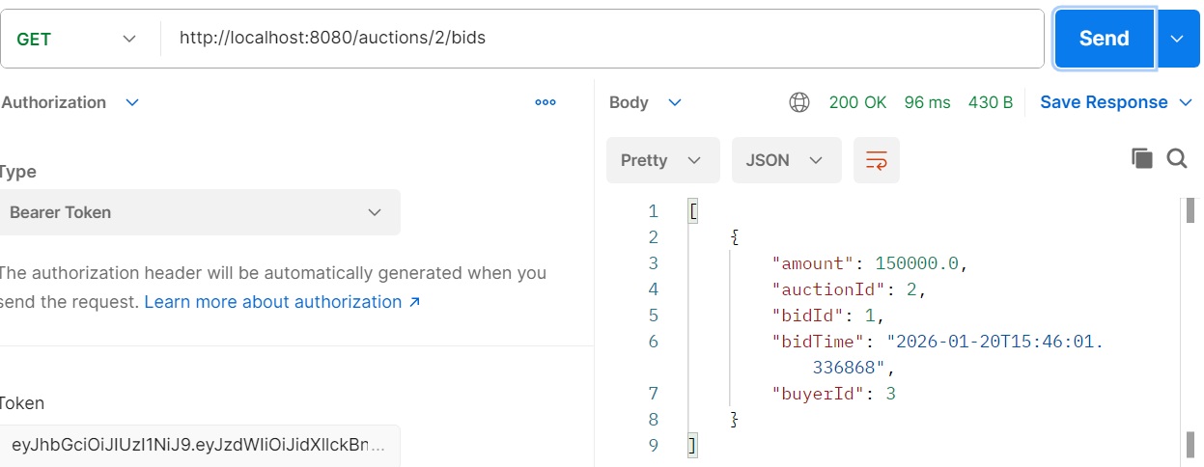
SELLER – view his product:
GET/products/seller/2
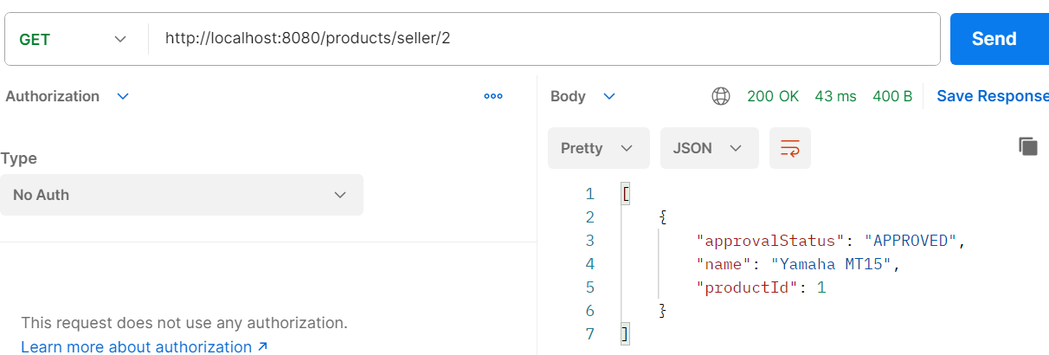

BUYER – view his bids:
GET/payments/1
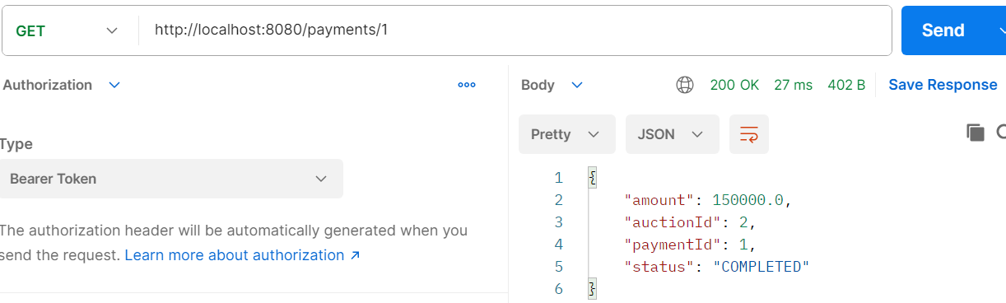
BUYER – view his highest bid:
GET/ auctions/2/highest-bid
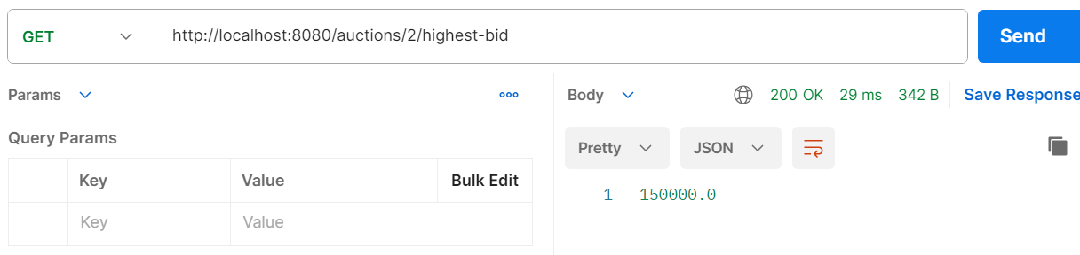
ADMIN- view the auctions
GET/admin/auctions
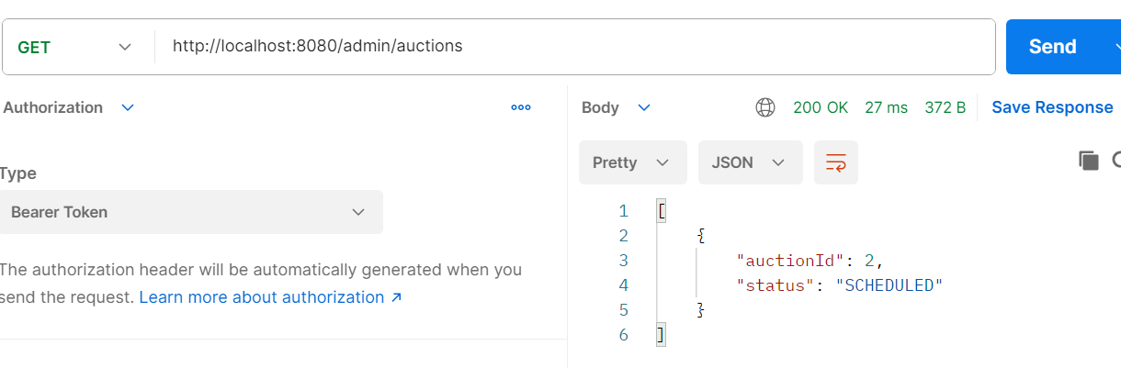
USER – view the users
GET/users
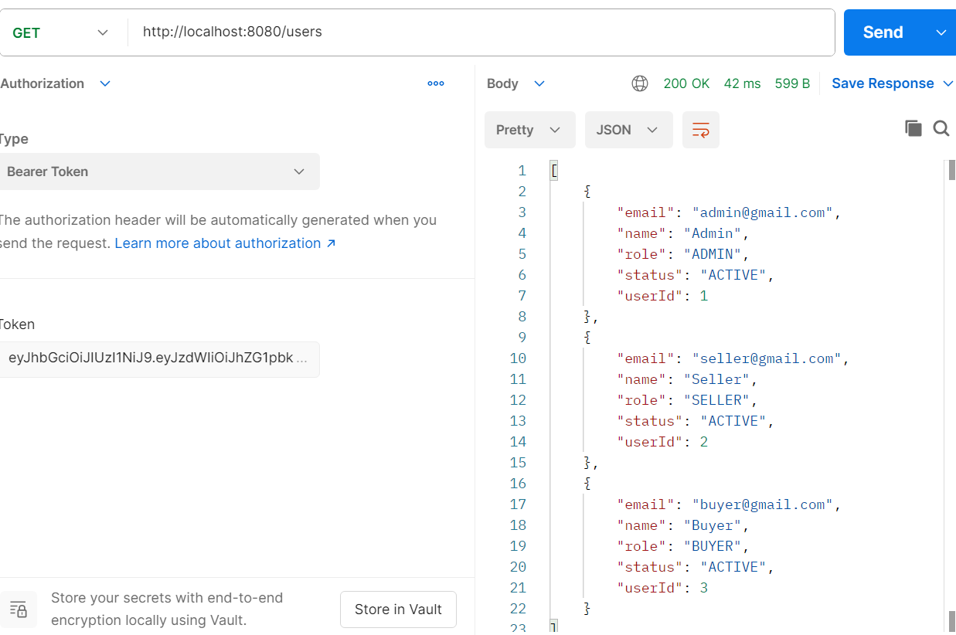
BUYER – forget-password:
PUT/users/forget-password/3
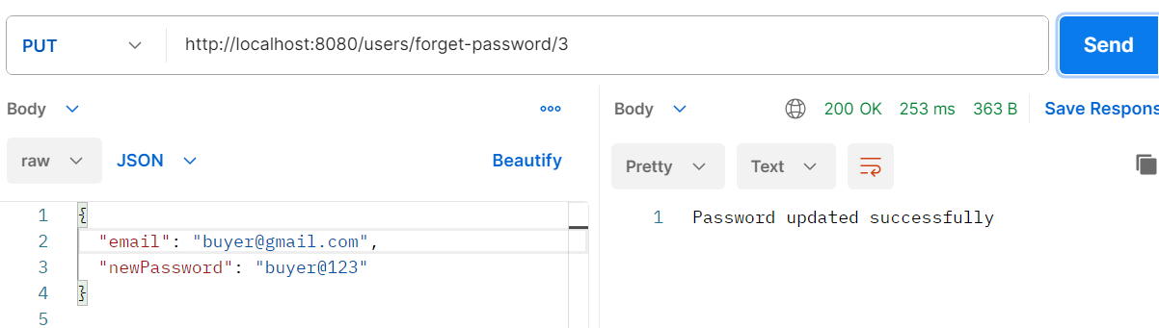
BUYER – reset-password:
PUT/users/reset-password/3
